Amazon | OA 2019 | Zombie in Matrix

LEET CODE : https://leetcode.com/discuss/interview-question/411357/

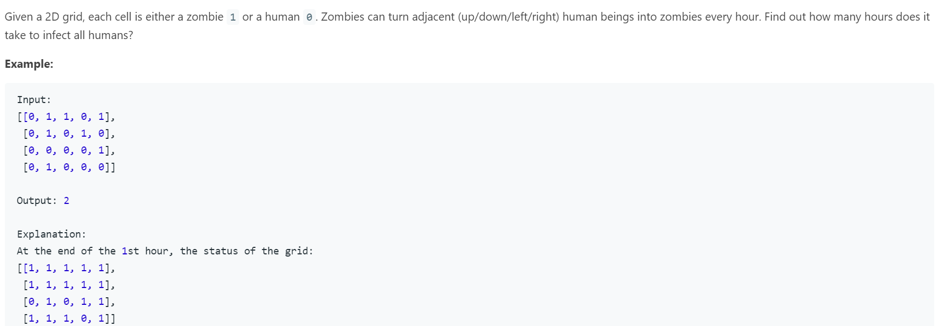

Ans :

public static void main(String[] args) {

int[][] grid = { { 0, 1, 1, 0, 1 }, { 0, 1, 0, 1, 0 }, { 0, 0, 0, 0, 1 }, { 0, 1, 0, 0, 0 } };

System.out.println(minDays(grid));

}

private static int minDays(int[][] grid) {

Queue<int[]> q = new LinkedList<>();

int target = grid.length \* grid[0].length;

int cnt = 0, res = 0;

for(int i=0;i<grid.length;i++) {

for(int j=0;j<grid[0].length;j++) {

if(grid[i][j] == 1) {

q.offer(new int[] {i,j});

cnt++;

}

}

}

int[][] dirs = {{0, 1}, {0, -1}, {1, 0}, {-1, 0}};

while(!q.isEmpty()) {

int size = q.size();

if(cnt == target)

return res;

for(int i=0;i<size;i++) {

int[] cur = q.poll();

for(int[] dir : dirs) {

int ni = cur[0] + dir[0];

int nj = cur[1] + dir[1];

if(ni >=0 && ni < grid.length && nj >=0 && nj < grid[0].length && grid[ni][nj] == 0) {

cnt++;

q.offer(new int[] {ni, nj});

grid[ni][nj] = 1;

}

}

}

res++;

}

return -1;

}

ALTERNATE:

private static int minDays(int[][] matrix) {

if (matrix == null || matrix.length == 0) {

return -1;

}

Queue<int[]> queue = new LinkedList<>();

int days = 0;

int humanCount = 0;

for (int i = 0; i < matrix.length; i++) {

for (int j = 0; j < matrix[0].length; j++) {

if (matrix[i][j] == 0) {

humanCount++;

} else {

queue.offer(new int[]{i, j});

}

}

}

int[][] directions = new int[][]{{0, 1}, {0, -1}, {-1, 0}, {1, 0}};

while (!queue.isEmpty() && humanCount > 0) {

int queueSize = queue.size();

for (int i = 0; i < queueSize; i++) {

int[] zombie = queue.poll();

for (int[] dir : directions) {

int newX = zombie[0] + dir[0];

int newY = zombie[1] + dir[1];

if (newX >= 0 && newX < matrix.length && newY >= 0 && newY < matrix[0].length && matrix[newX][newY] == 0) { // when the new coordinates doesn't exceed the boundaries of the matrix or the new valid coordinate is a human, only then turn that to a zombie

matrix[newX][newY] = 1;

queue.offer(new int[]{newX, newY}); // now that new coordinate is a zombie, add that to the queue so it can be processed in the next level

humanCount--;

}

}

}

days++;

}

return humanCount == 0 ? days : -1;

}